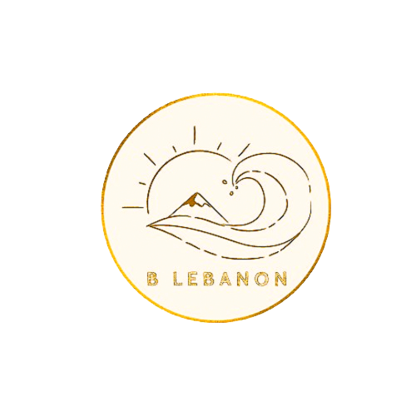

B Lebanon

a tourist guide

Lana Alameddine | Riwa Hammoud

Despite the fact that life in Lebanon is challenging, we are happy to have created a guide to show you the country's beautiful sights, along with interesting things to do, wonderful comfortable places to stay, and excellent restaurants.